Student Performance Prediction System

Problem Id: 7

Student Name- Smriti Singh

University Roll number- 2028859

Section G

Student Name- Sanya Verma

University Roll number- 2028839

Section-G

- Problem Description 3
- Architecture 4
- Models model 5
- Evaluation metrics used 6
- Preliminary Results and Visualizations 7
- References 8

- Problem Description

Type-2 Diabetes is a rapidly increasing health condition that affects millions of people worldwide. Early detection of diabetes is challenging because symptoms may not appear in the initial stages, leading to delayed diagnosis and serious complications such as heart disease, kidney failure, and vision loss.
Traditional methods of diagnosis require continuous medical testing and expert analysis, which can be time-consuming and may not always be accessible to everyone. There is a need for an automated system that can quickly analyze patient data and predict the risk of diabetes accurately.
This project aims to develop a machine learning-based Clinical Risk Assessment system that uses patient health data such as glucose level, BMI, age, blood pressure, and insulin levels to predict whether a person is diabetic or not. By applying data preprocessing, exploratory data analysis (EDA), and classification algorithms, the system identifies important patterns and risk factors associated with diabetes.
The proposed system helps in early prediction, reduces manual effort, and supports healthcare professionals in making data-driven decisions for better diagnosis and treatment.

2.Architecture

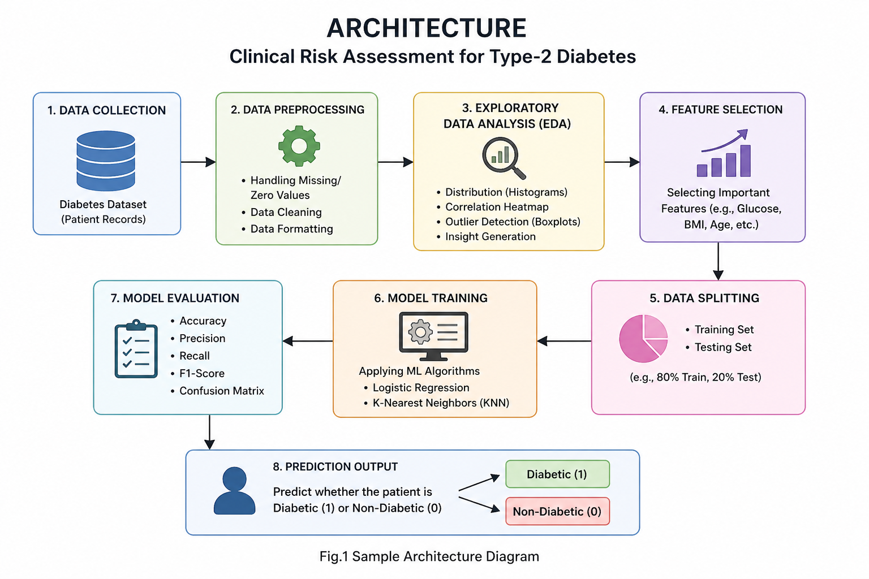

3. Models Used (Applied / Planned)

In this project, machine learning classification algorithms are used to predict whether a patient is diabetic or non-diabetic based on clinical data.
1. Logistic Regression (Applied)
Logistic Regression is a supervised machine learning algorithm used for binary classification problems. It predicts the probability of an outcome using a sigmoid function, which maps values between 0 and 1. In this project, it is used to classify patients as diabetic (1) or non-diabetic (0) based on input features like glucose, BMI, and age. It is simple, efficient, and performs well for linearly separable data.

2. K-Nearest Neighbors (KNN) (Applied)
K-Nearest Neighbors is a non-parametric algorithm that classifies a data point based on the majority class of its nearest neighbors. It calculates the distance (usually Euclidean distance) between data points to determine similarity. In this project, KNN helps in predicting diabetes by comparing a patient’s data with similar existing records.

3. Decision Tree (Planned)
Decision Tree is a supervised learning algorithm that splits the dataset into branches based on feature conditions. It forms a tree-like structure where each node represents a decision rule. It is easy to interpret and helps in identifying important features affecting diabetes prediction.

4. Random Forest (Planned)
Random Forest is an ensemble learning method that combines multiple decision trees to improve prediction accuracy and reduce overfitting. It provides better generalization and is robust for complex datasets.

4. Evaluation metrics used

To evaluate the performance of the machine learning models used for predicting Type-2 Diabetes, the following evaluation metrics are applied:
1. Accuracy
Accuracy measures the overall correctness of the model. It is the ratio of correctly predicted instances to the total number of instances.
It gives a general idea of how well the model is performing.

2. Precision
Precision measures how many of the predicted diabetic cases are actually diabetic.
It is important when false positives need to be minimized.

3. Recall (Sensitivity)
Recall measures how many actual diabetic patients are correctly identified by the model.
It is very important in healthcare applications because missing a diabetic patient can be risky.

4. F1-Score
F1-Score is the harmonic mean of precision and recall.
It provides a balance between precision and recall, especially useful when the dataset is imbalanced.

5. Confusion Matrix
A confusion matrix is used to visualize
the performance of the model by showing:
- True Positives (TP): Correctly predicted diabetic cases
- True Negatives (TN): Correctly predicted non-diabetic cases
- False Positives (FP): Incorrectly predicted diabetic cases
- False Negatives (FN): Missed diabetic cases

5. Preliminary Results and Visualizations

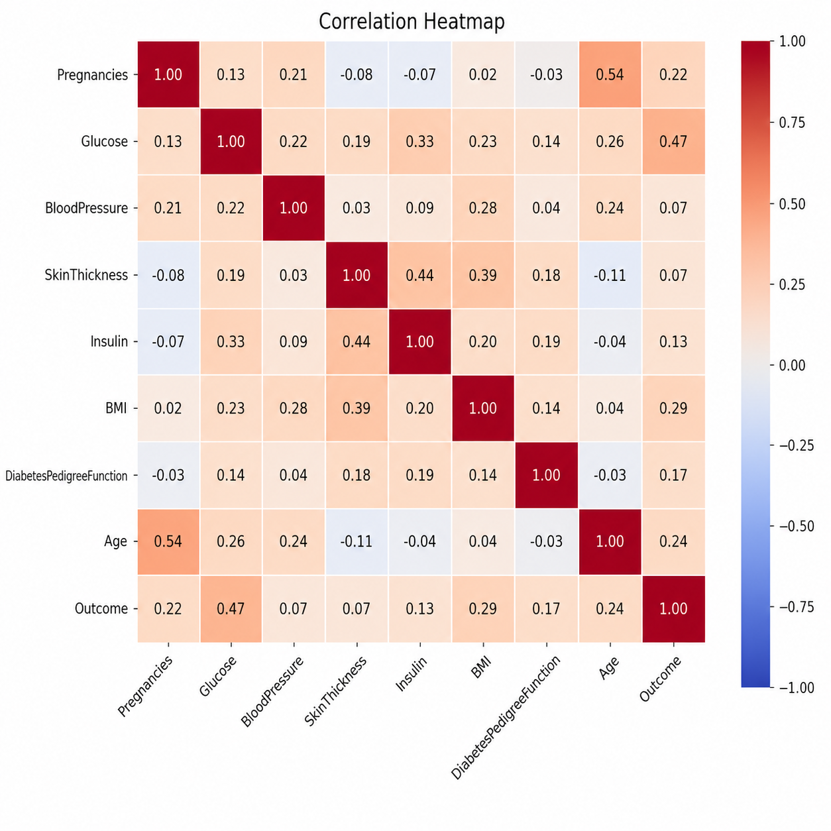

6. References:
Books:
- Let Us Python – Yashavant Kanetkar

Online Resources:
- GeeksforGeeks – https://www.geeksforgeeks.org/
- TutorialsPoint – https://www.tutorialspoint.com/
- Stack Overflow – https://stackoverflow.com/

Libraries & Tools Used:
- Python Programming Language
- NumPy Library
- Pandas Library
- Matplotlib Library
- Seaborn Library
- Scikit-learn Library

Dataset Source:
- PIMA Indians Diabetes Dataset (commonly used dataset for diabetes prediction)

